**Create New Virtual Machine:**

1. [https://portal.azure.com/](https://portal.azure.com/#home) and click on “Virtual Machine” link

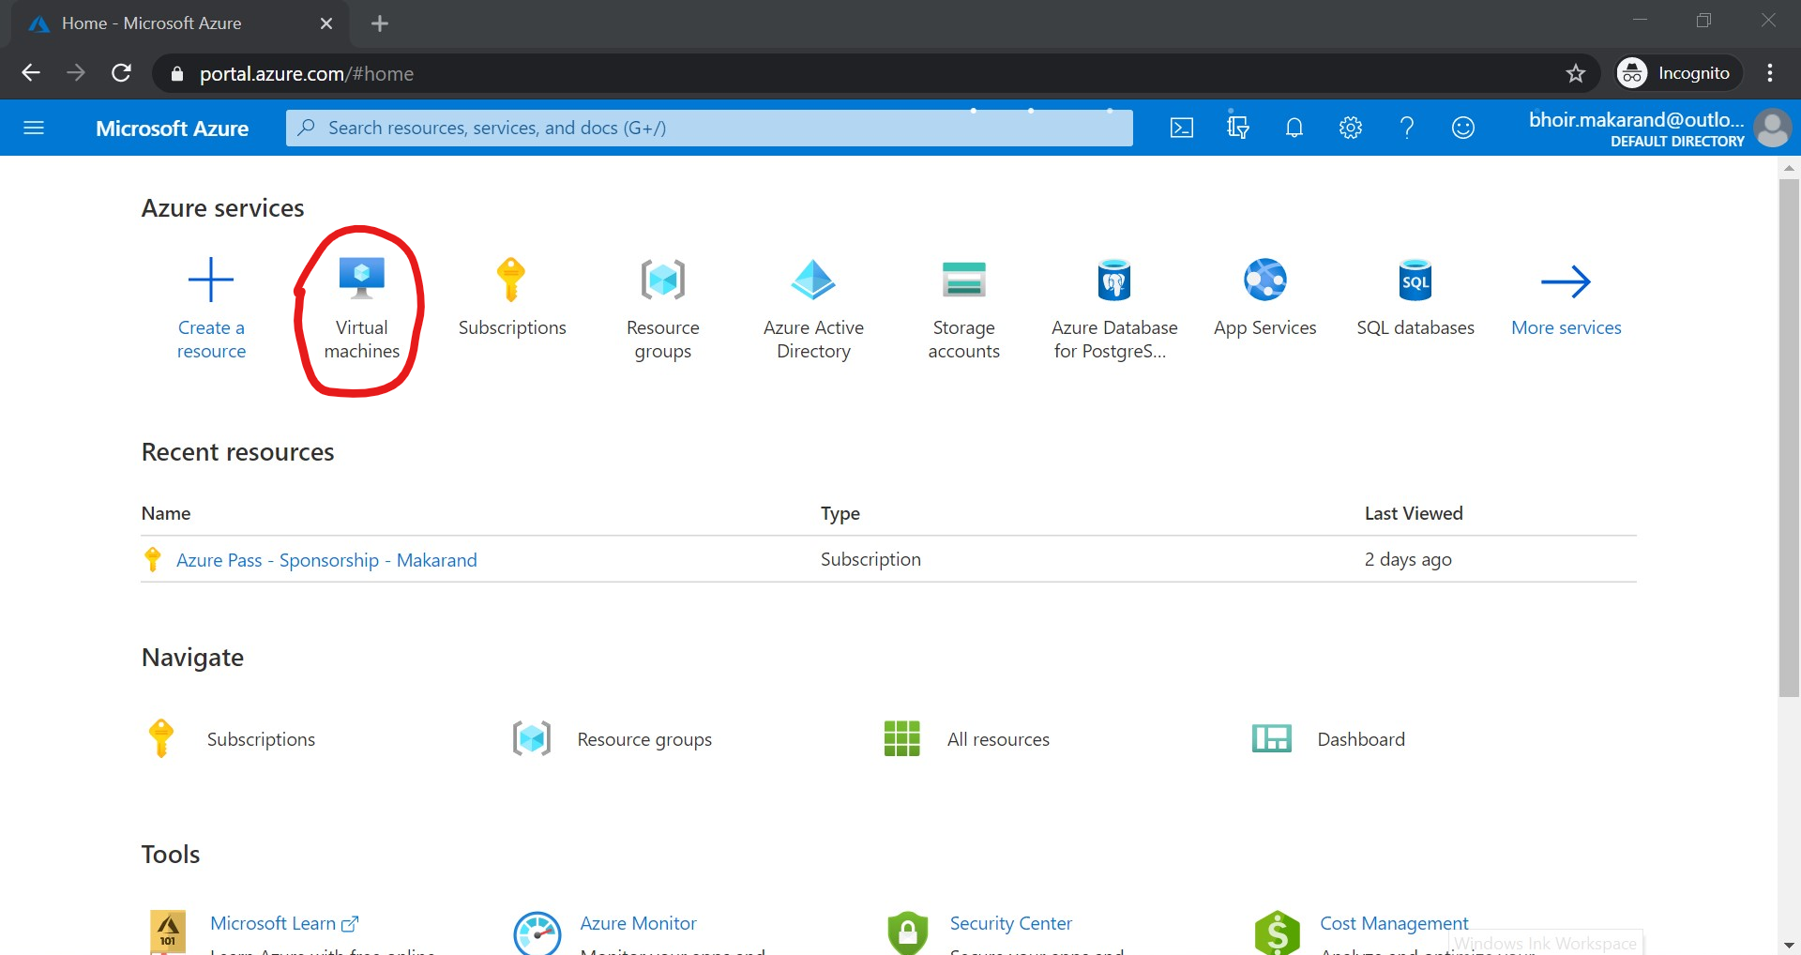

1. Then click on “Add” link

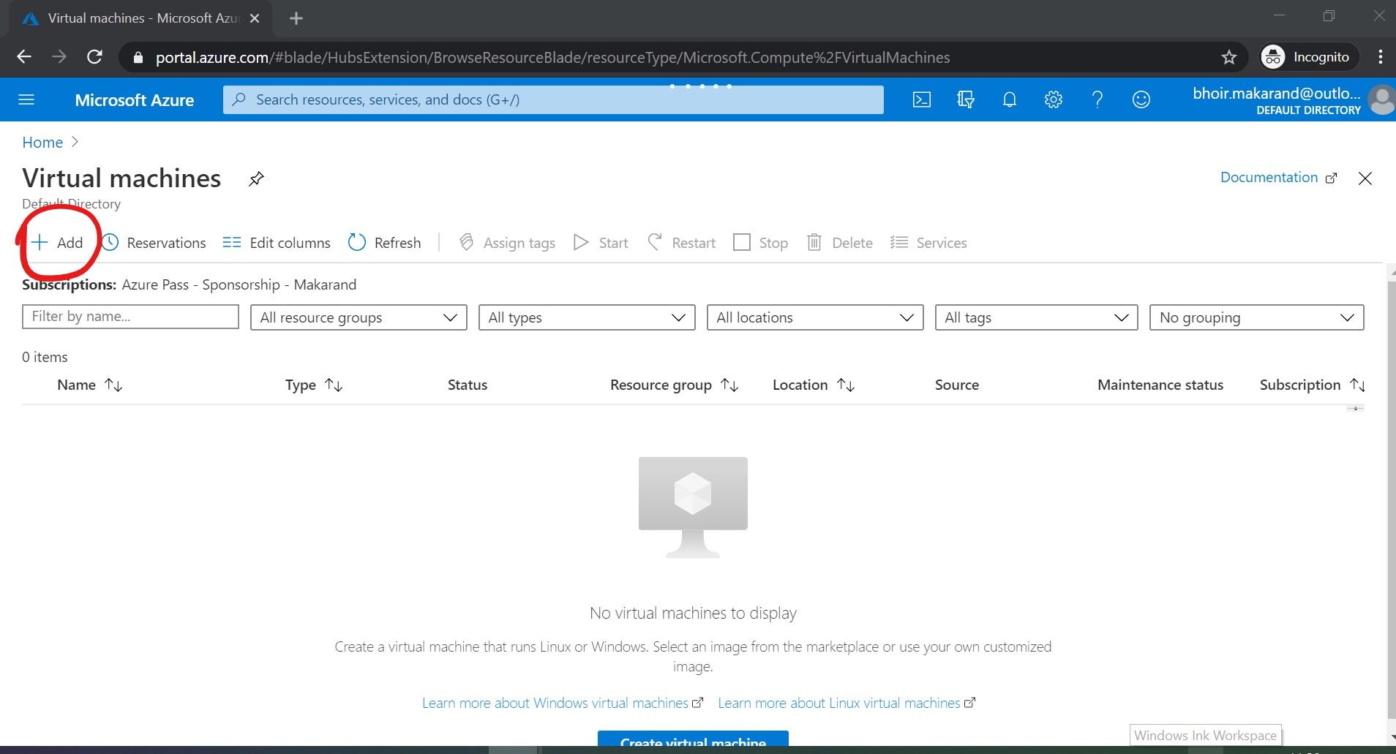

1. Specify name of your virtual machine and scroll down the page

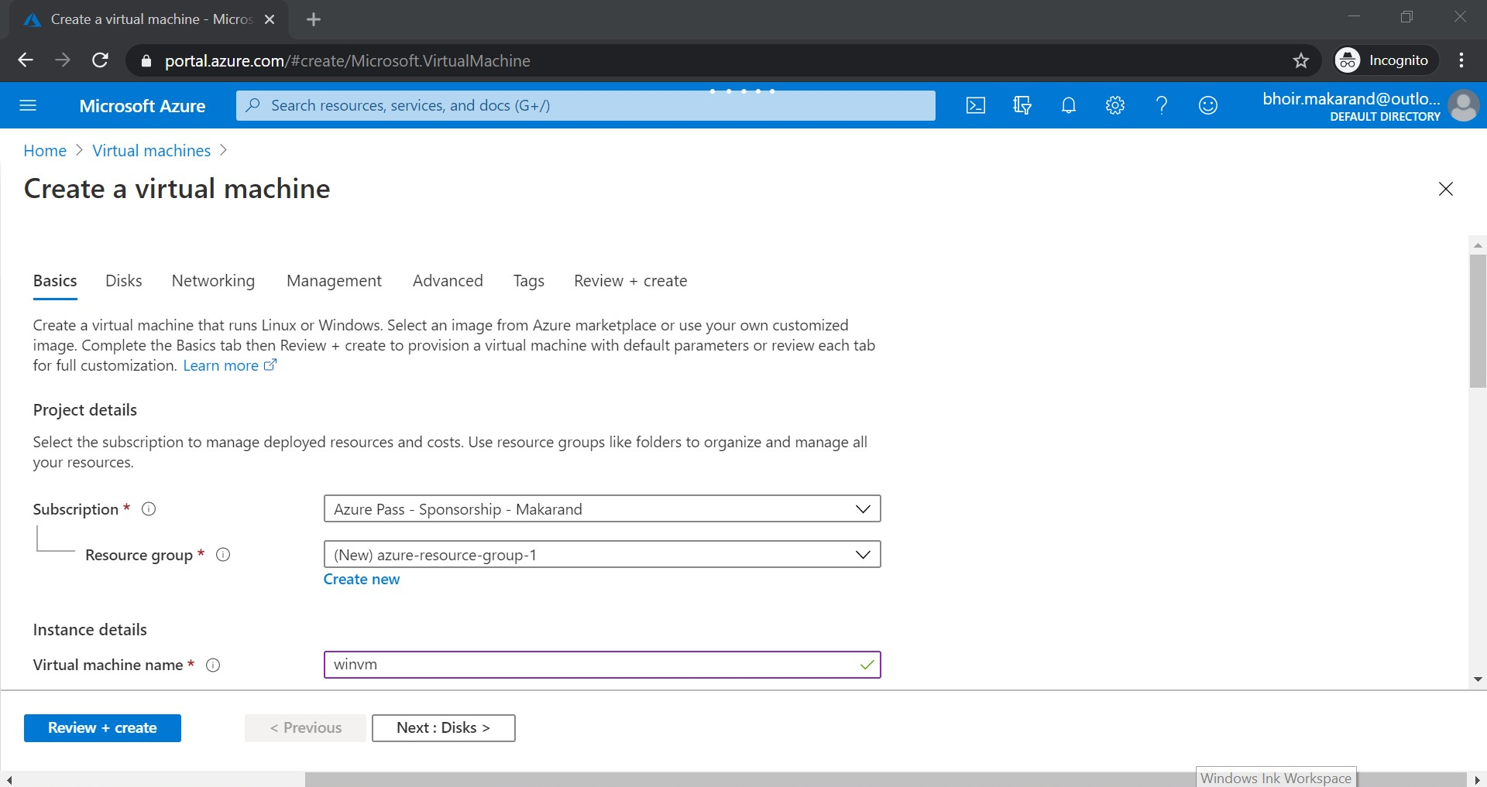

1. Select the image as “Windows server 2016 Datacenter” and specify your new credential of virtual machine. Scroll down to the page

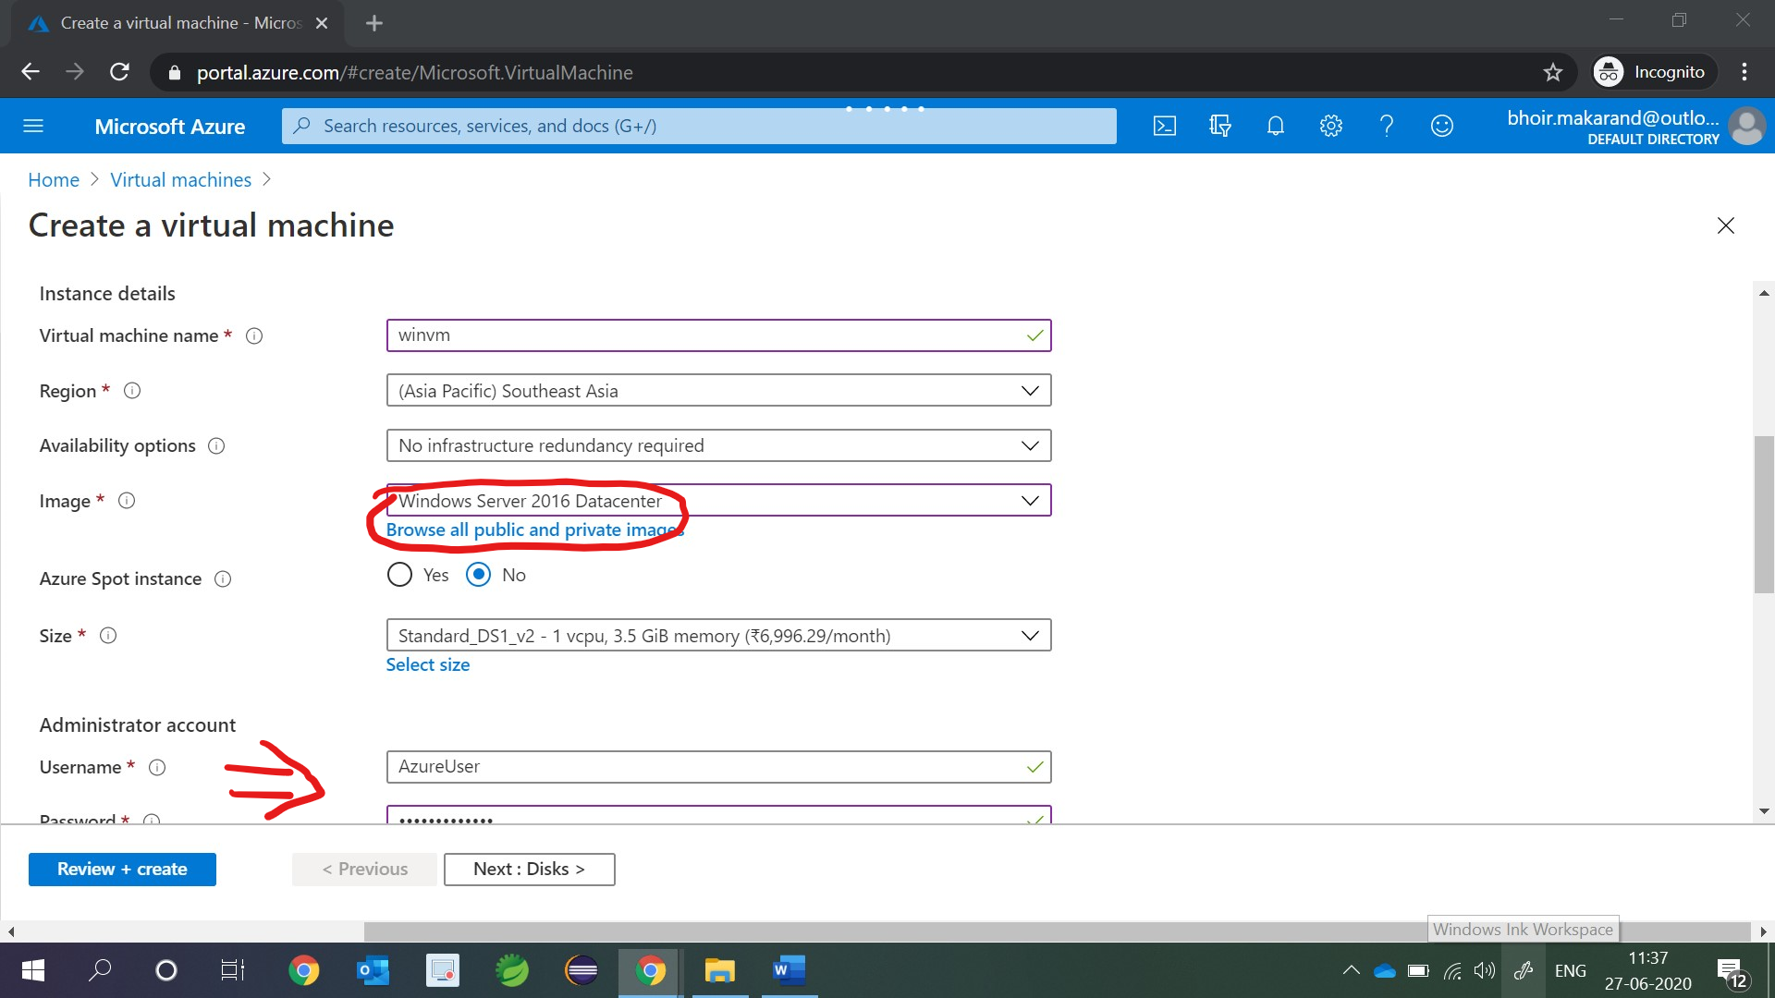

1. Enable Remote Desktop Port (RDP) and click on “Next: Disks” button

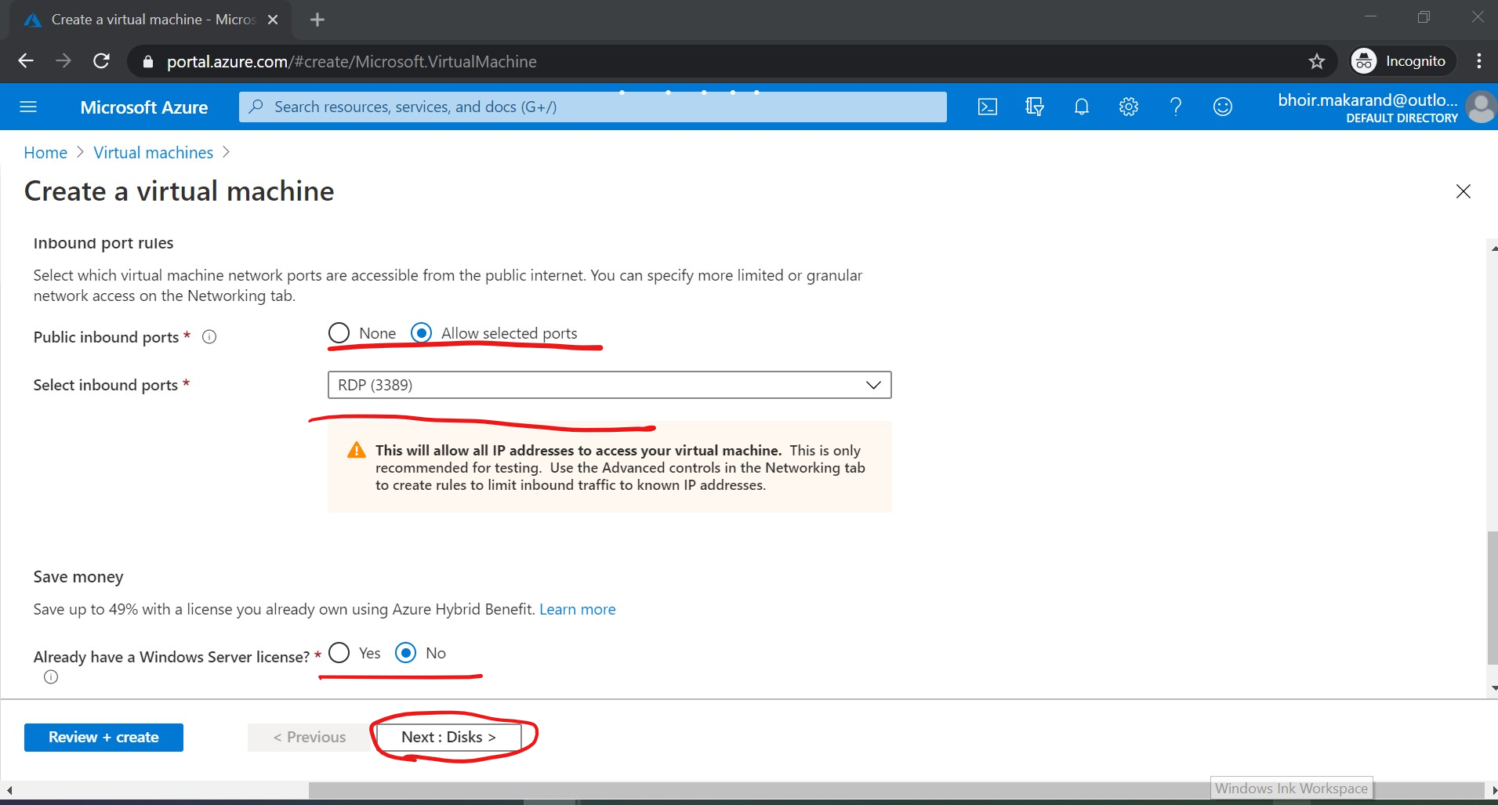

1. Select disk type as “Standard HDD” and click on “Next: Networking” button

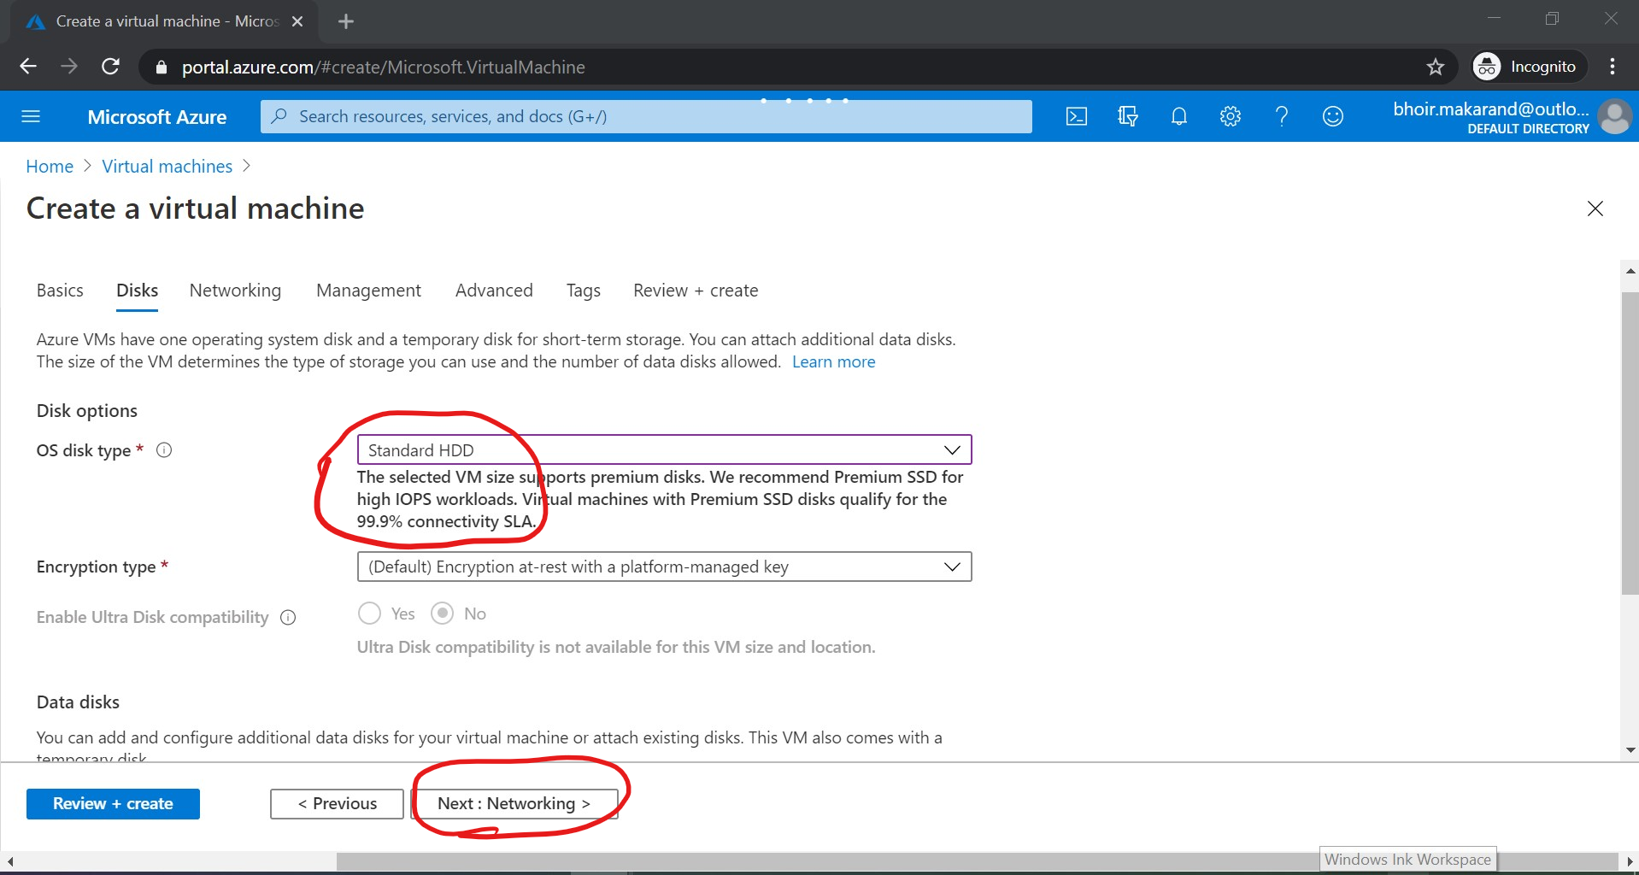

1. Create new network as specified in screenshot below

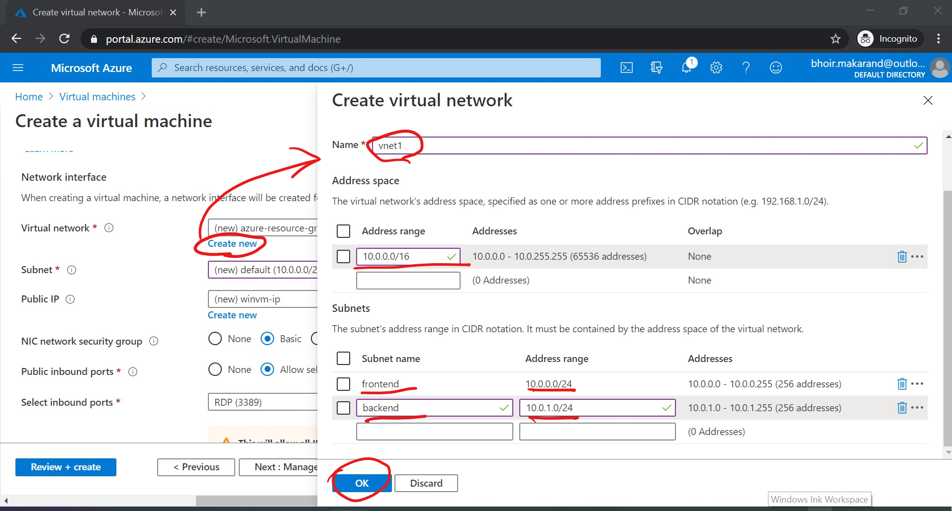

1. Select the subnet as frontend and public IP (since we will access VM from outside) and click on “Next: Management” button

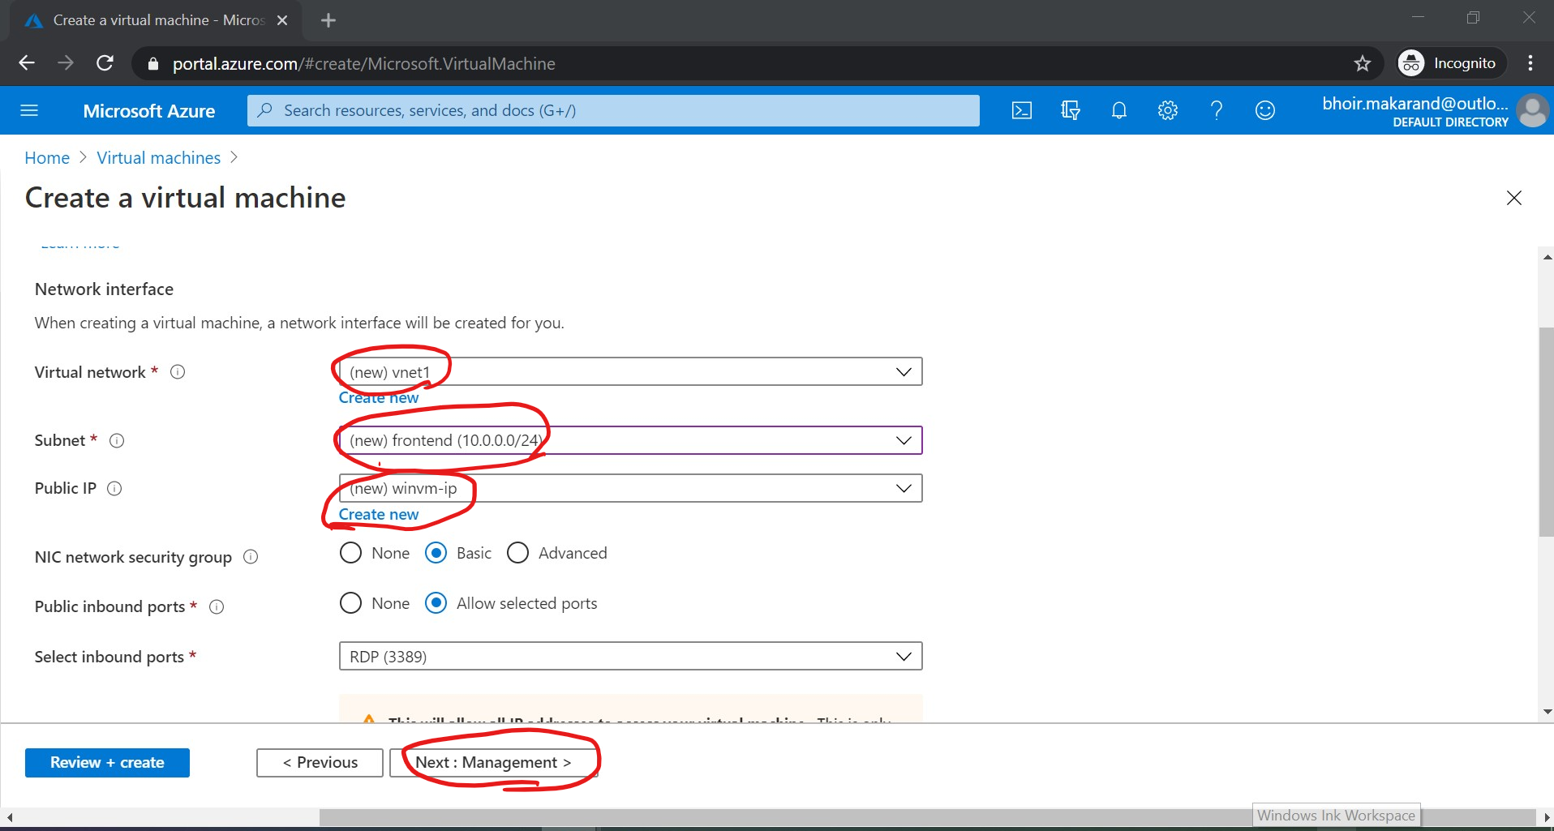

1. Select as specified in Management screen below and click on “Review + create” button

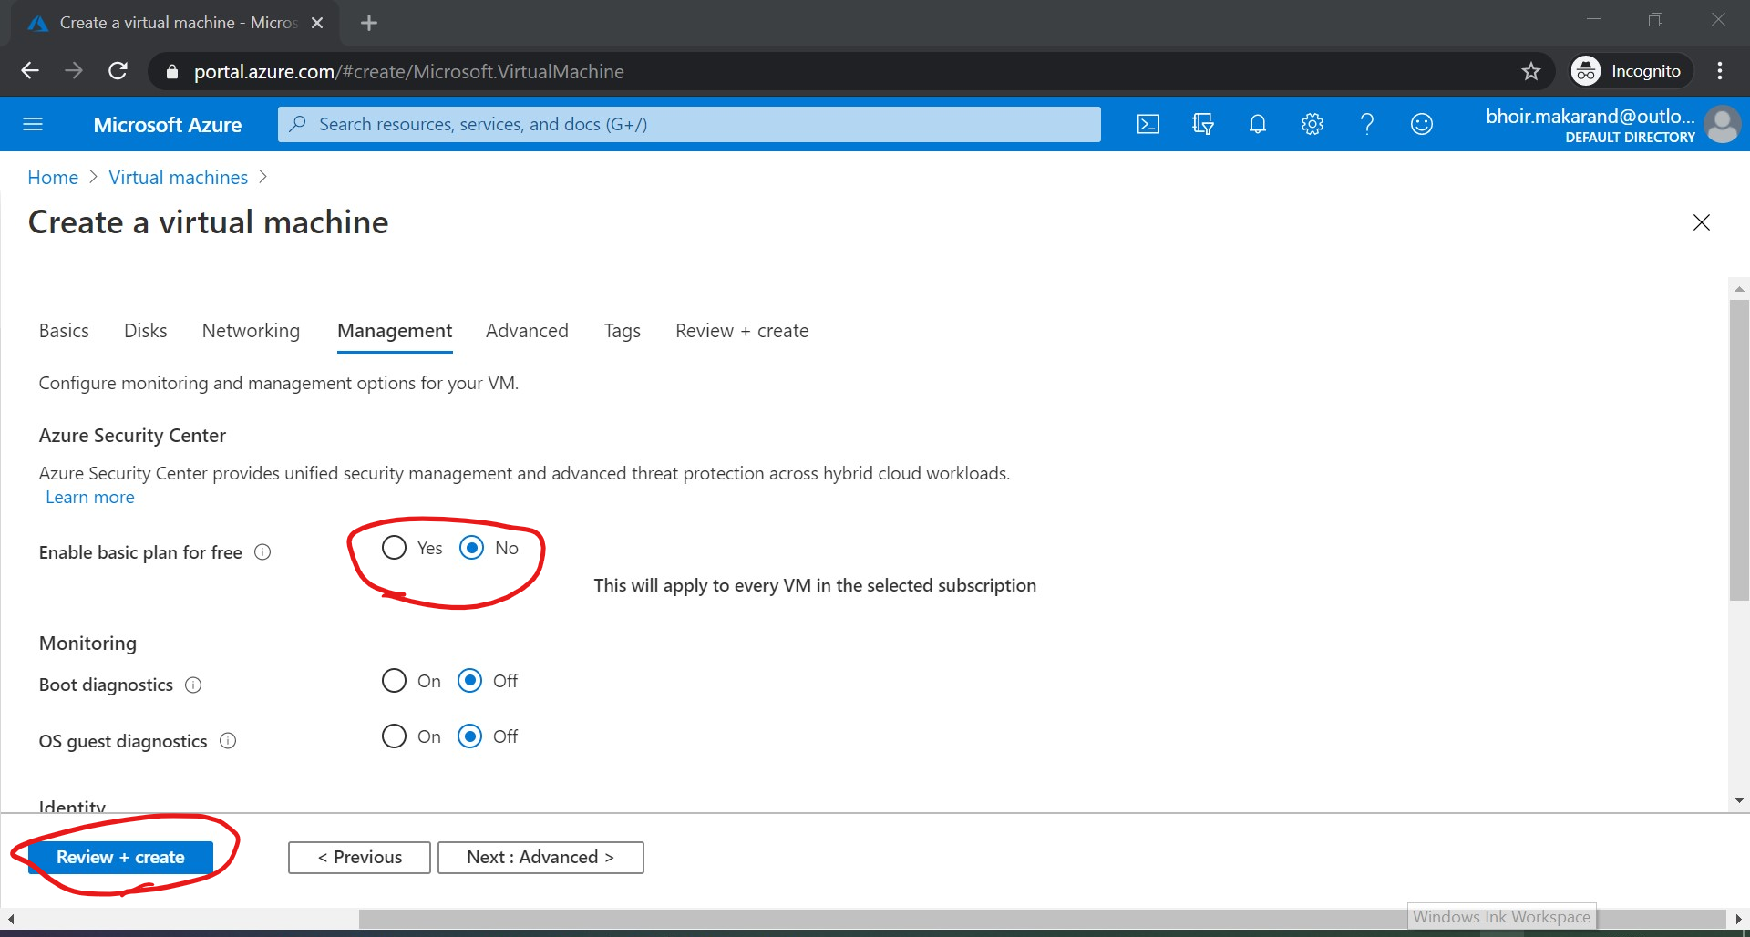

1. Validation passed will be displayed. You can check price per hour and click on “Create” button

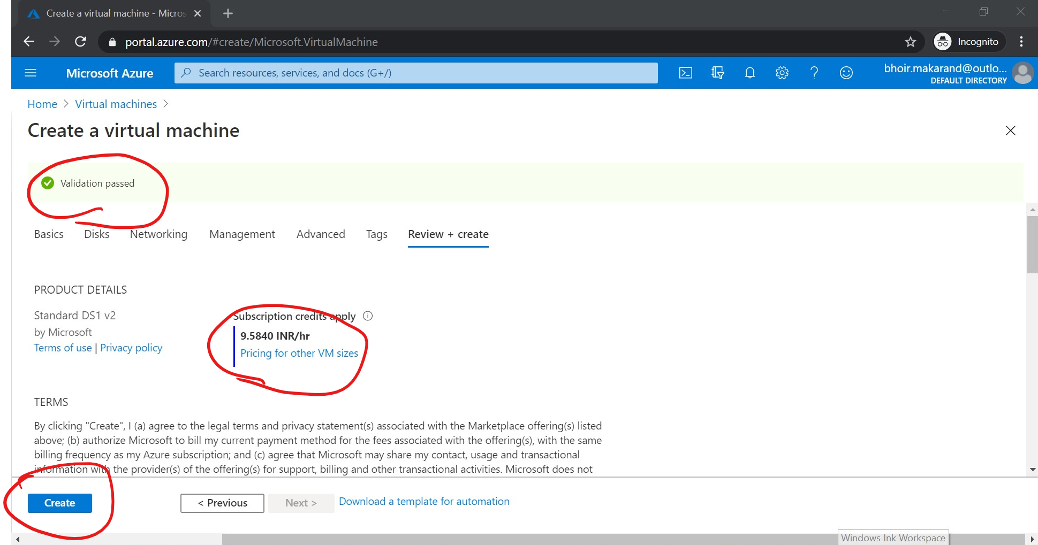

1. Added virtual machine you will be able to see under virtual machine section. Click on winvm (virtual machine name) that you had created

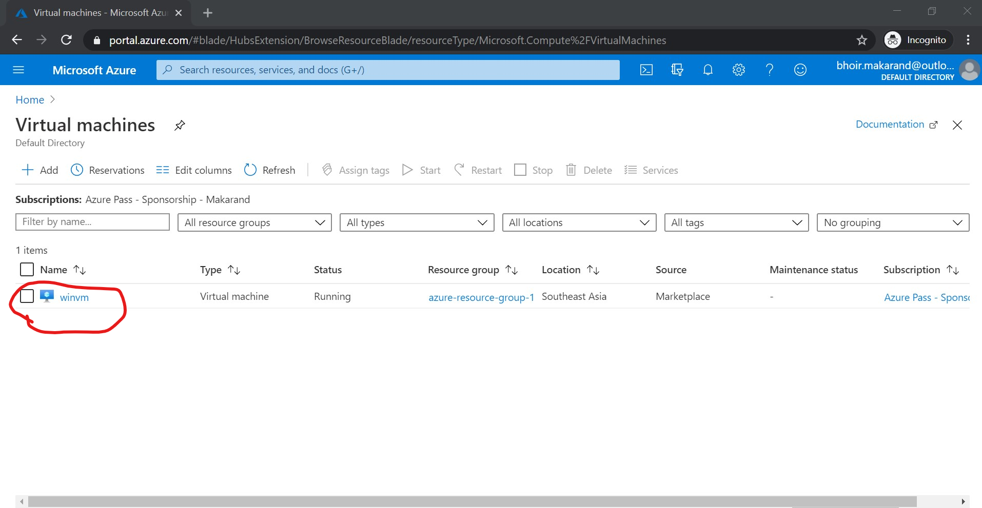

1. Click on Connect button then it will allow you to download virtual machine file

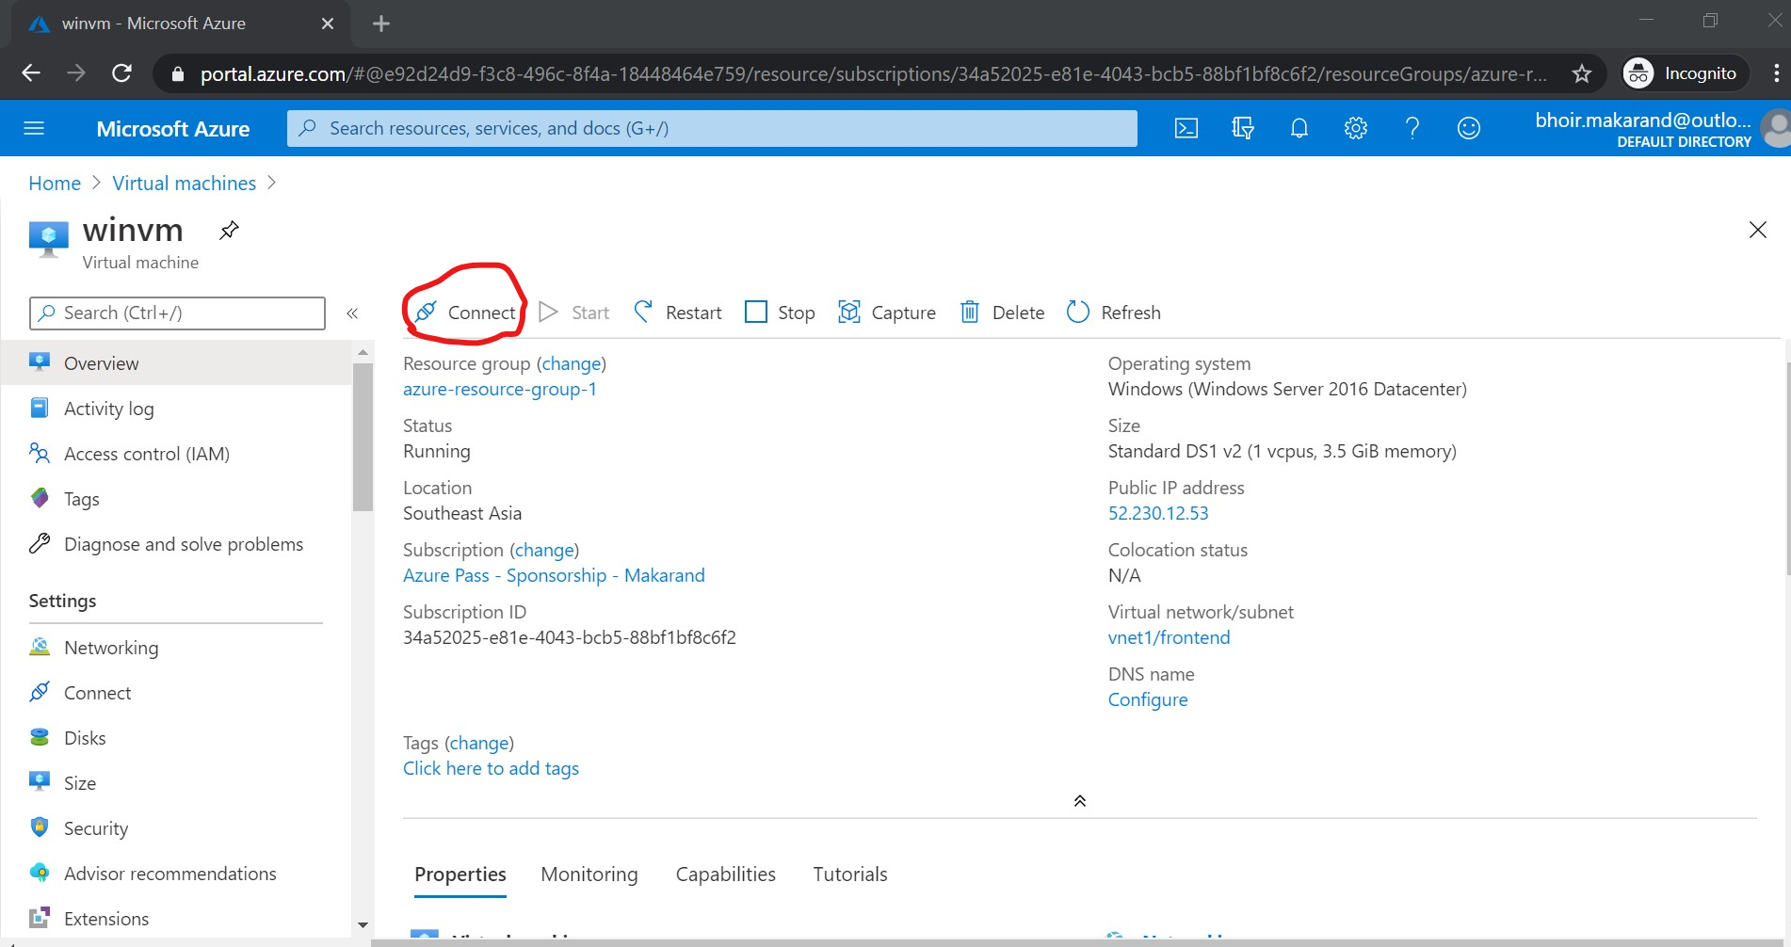

1. Note public IP of your virtual machine (52.230. 12. 53) Click on Download RDP file

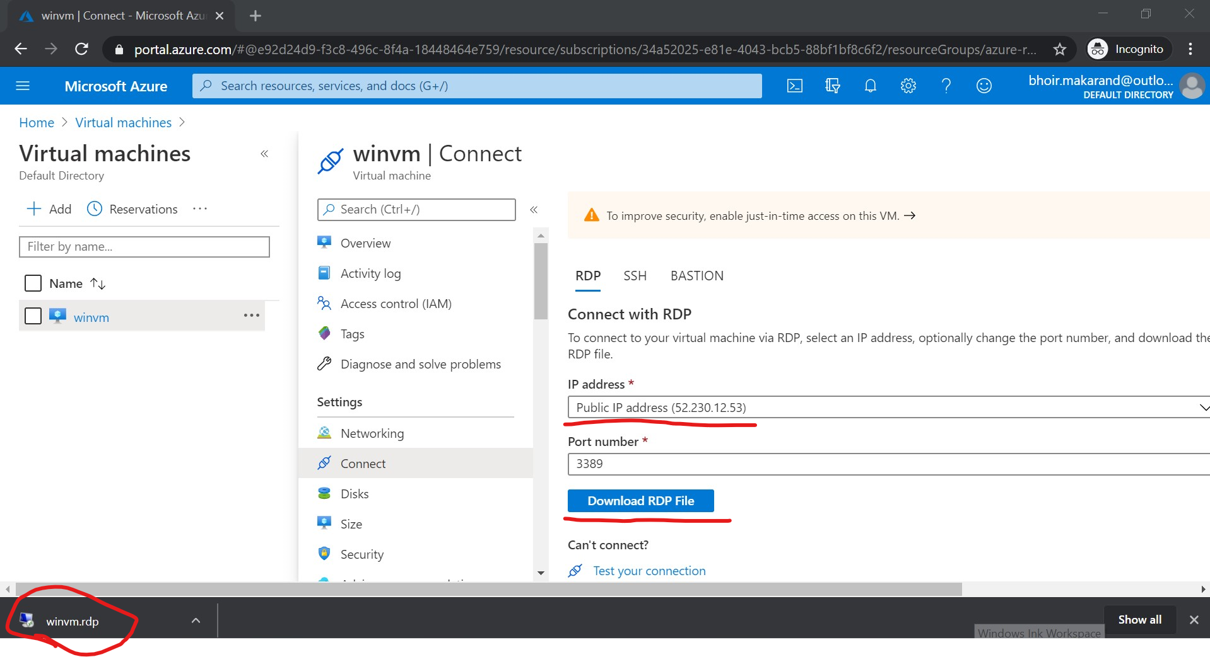

1. Double click on winvm.rdp file it will ask you credential and click on “OK” button

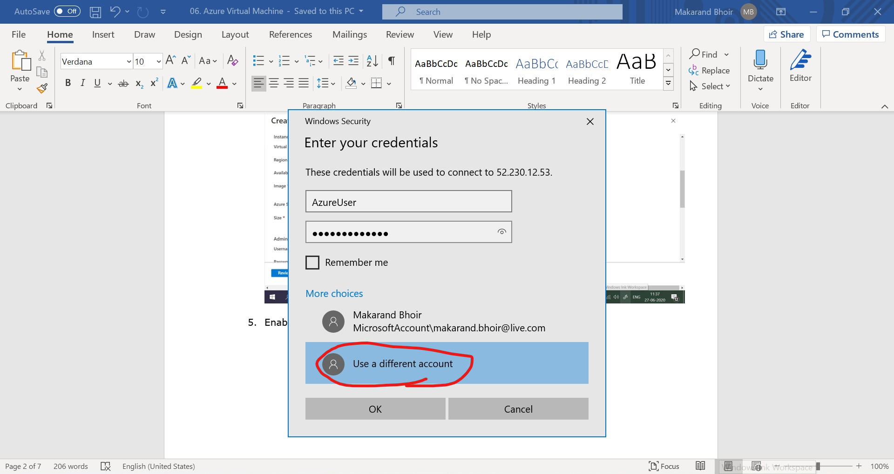

1. It will take you to the Virtual Machine’s Desktop.

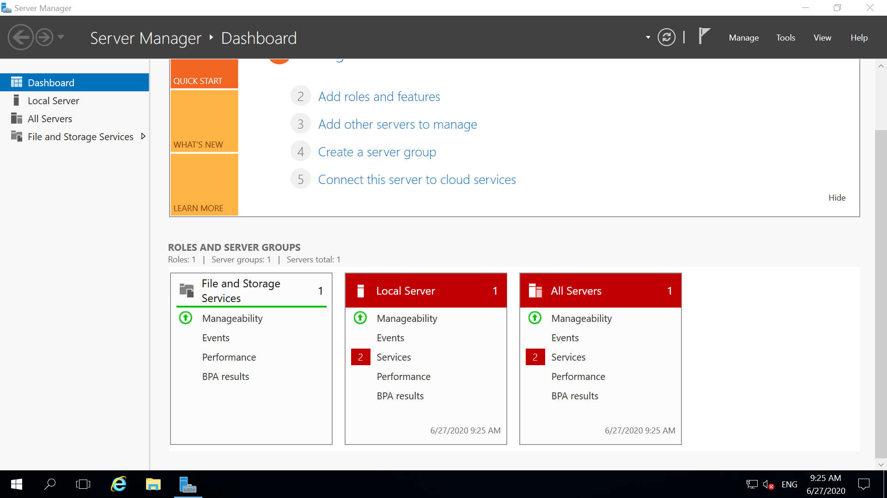

1. Close the server manager dashboard. And will show you VM’s Desktop

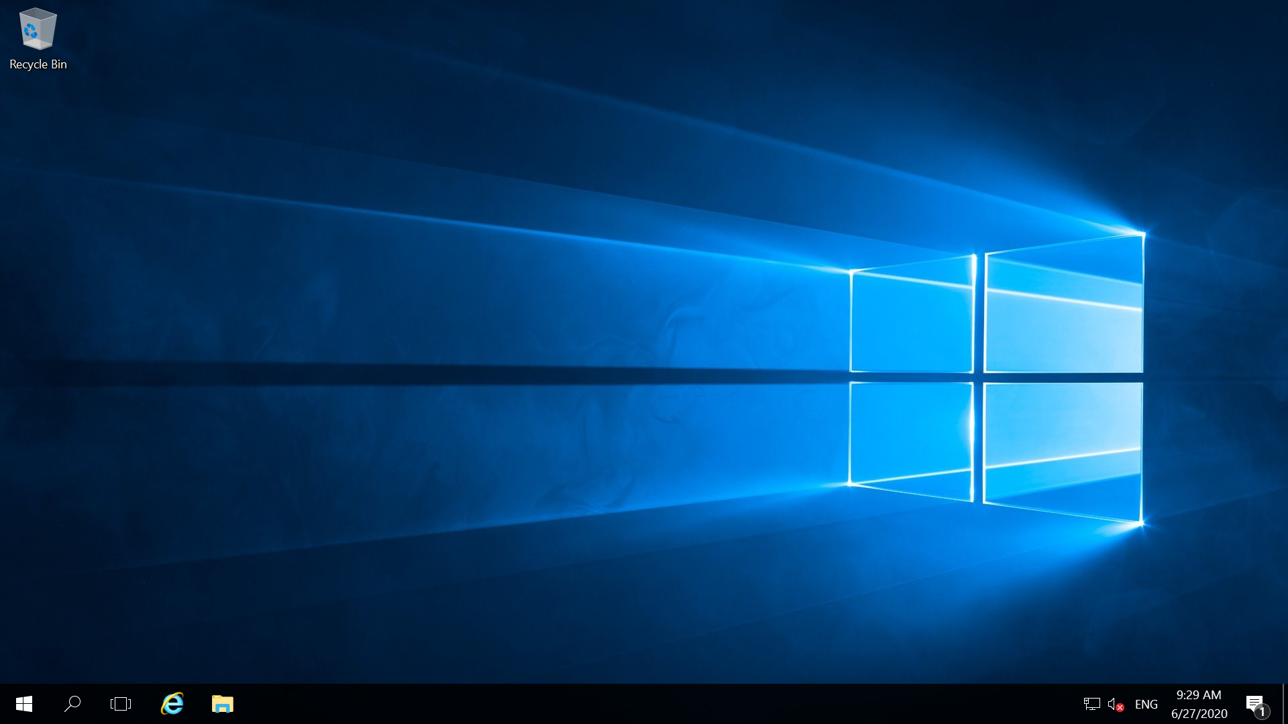

1. Open browser and download Tomcat 9 on your virtual machine

